TEMPORARY TENT PERMIT APPLICATION PROCESS
(Tents at Windsor Castle Park)
Tent permits are an Isle of Wight County requirement and do not go through the Town of Smithfield.
If you have any questions about the permit or the permitting process please reach out to Chrystalyn Brown, Windsor Castle Park Site Manager at cbrown@smithfieldva.gov or to the county directly at planreview@isleofwightus.net.
The following must be submitted:
- Complete highlighted sections of General (Tent) Permit application (Page 2)
- If you are applying for the permit as an individual and not a tent company, please complete and sign the Liability Form. (Page 3)
Obtain from Tent Company:
- PDF illustration of tents floor plan with exits marked on diagram. (Example below)
- Certificate of Flame Resistance (Example below)
Email these documents to planreview@isleofwightus.net (This is the fastest method)
Application packet may also be mailed to
Central Permitting
P O Box 80
Isle of Wight, VA 23397

or hand delivered to
Central Permitting
17140 Monument Circle #101
Isle of Wight, VA 23397

*mailing or hand delivering packet requires 2 sets of tent floor plan.

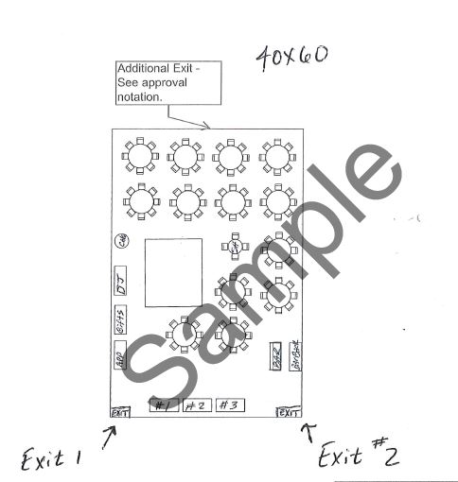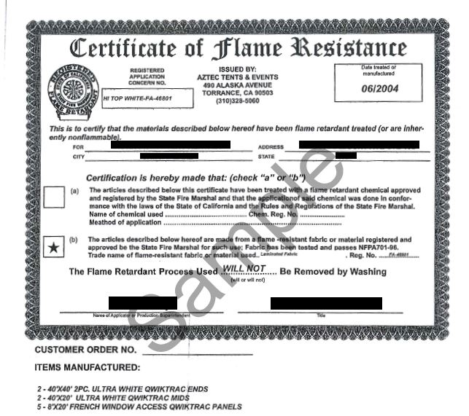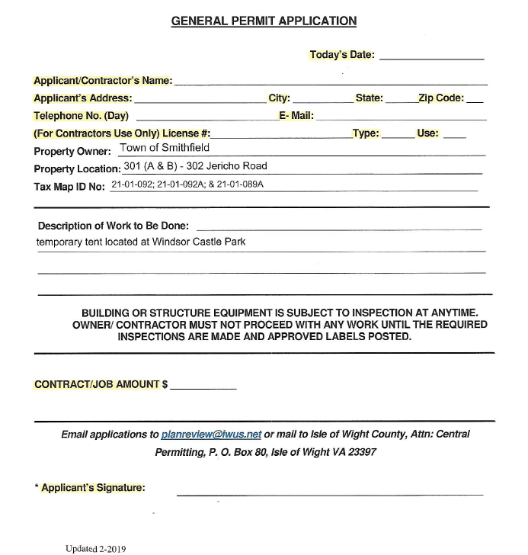
Tent Floor Plan with Exits Example
Certificate of Flame Resistance Example

